Name: DAGDAG J Adonai Student ID: 130369824

1. Selected theme:

2nd hand online shop/ Ad posting website

1. Description about your business:

Users can post their ads for selling their smartphones, tablets, PCs, laptops, and computer components. It is a simplified version of eBay.

1. How your website achieves your business purpose:

This website is user friendly as it is a responsive design which users can easily locate the products they desire.

1. How you made your website look good and user-friendly:

Template

For the main template I used the following link:

<http://www.w3schools.com/w3css/tryw3css_templates_portfolio.htm>

For the homepage (Assignment 01.html), I used the slide show from the following template link: <http://www.w3schools.com/w3css/tryw3css_templates_marketing.htm>

Layout

All 4 pages have responsive design. All 4 pages has a different header but have common footer.

Details

All the hovering parts are edited by me. I only used the template for the background and sliders. The arrangements on the footer are done by myself. Also the sidebar are edited by me.

Screen capture of your website:

Page 01:

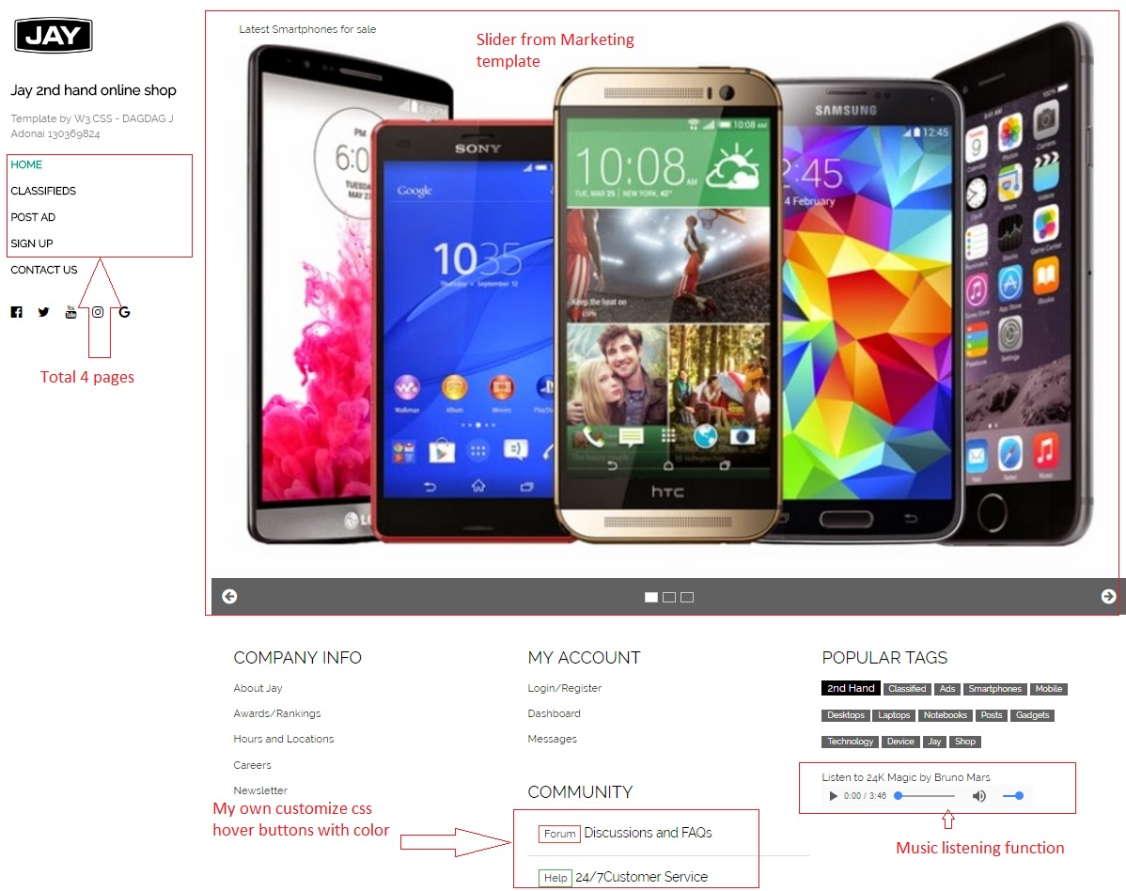

Page 02: Ads section with category selection

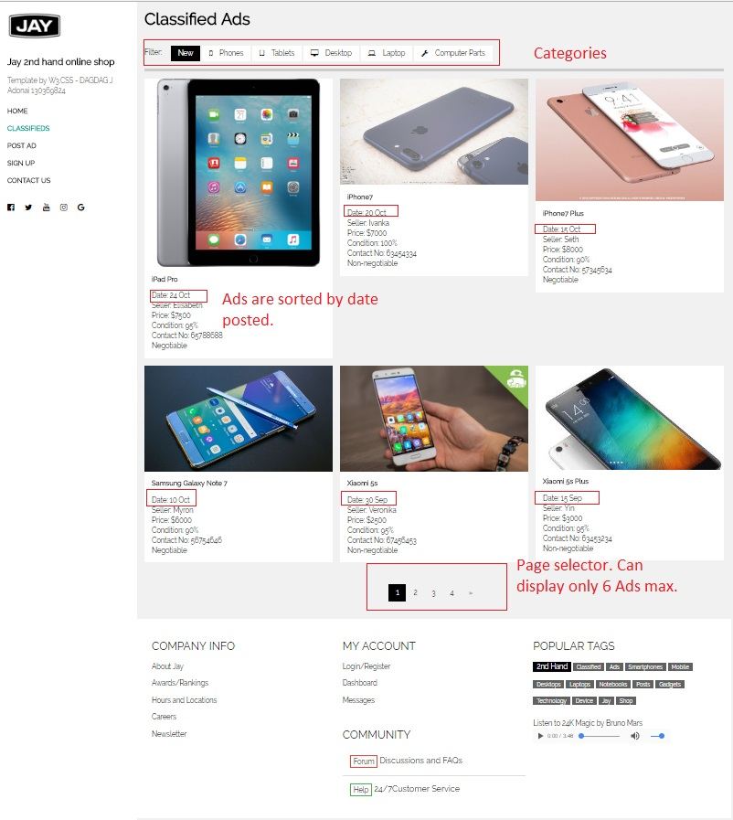

Page 03: Post Ad form

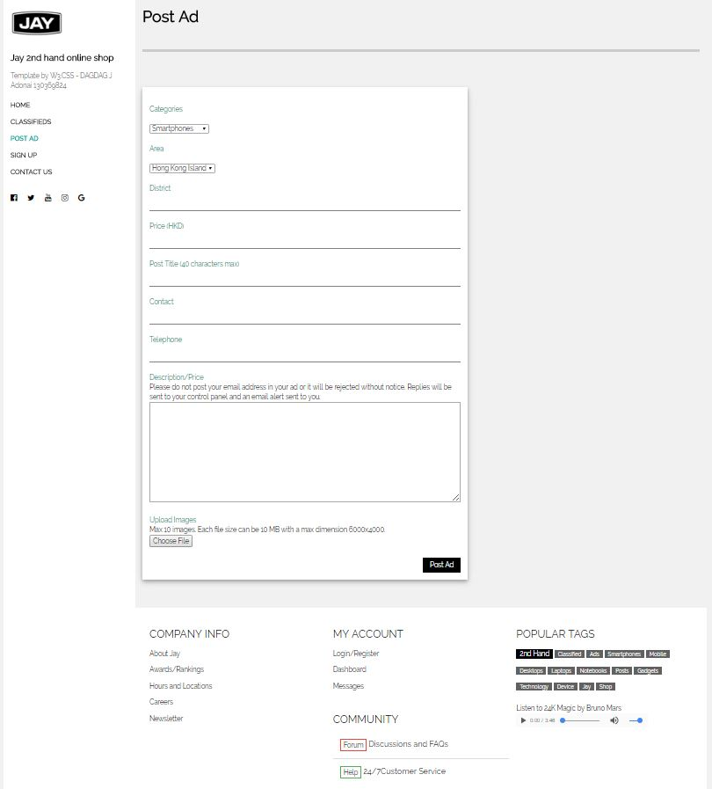

Page 04: Sign up form

